1.Implement and demonstrate the FIND-S algorithm for finding the most specific hypothesis based on a given set of training data samples.

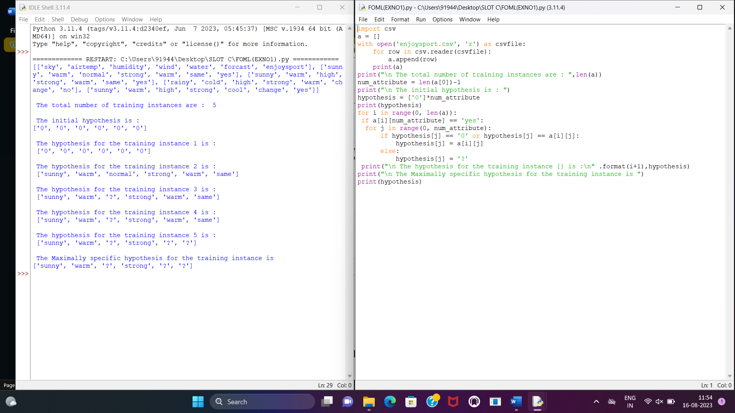

2.For a given set of training data examples stored in a .CSV file, implement and demonstrate the Candidate-Elimination algorithm in python to output a description of the set of all hypotheses consistent with the training examples

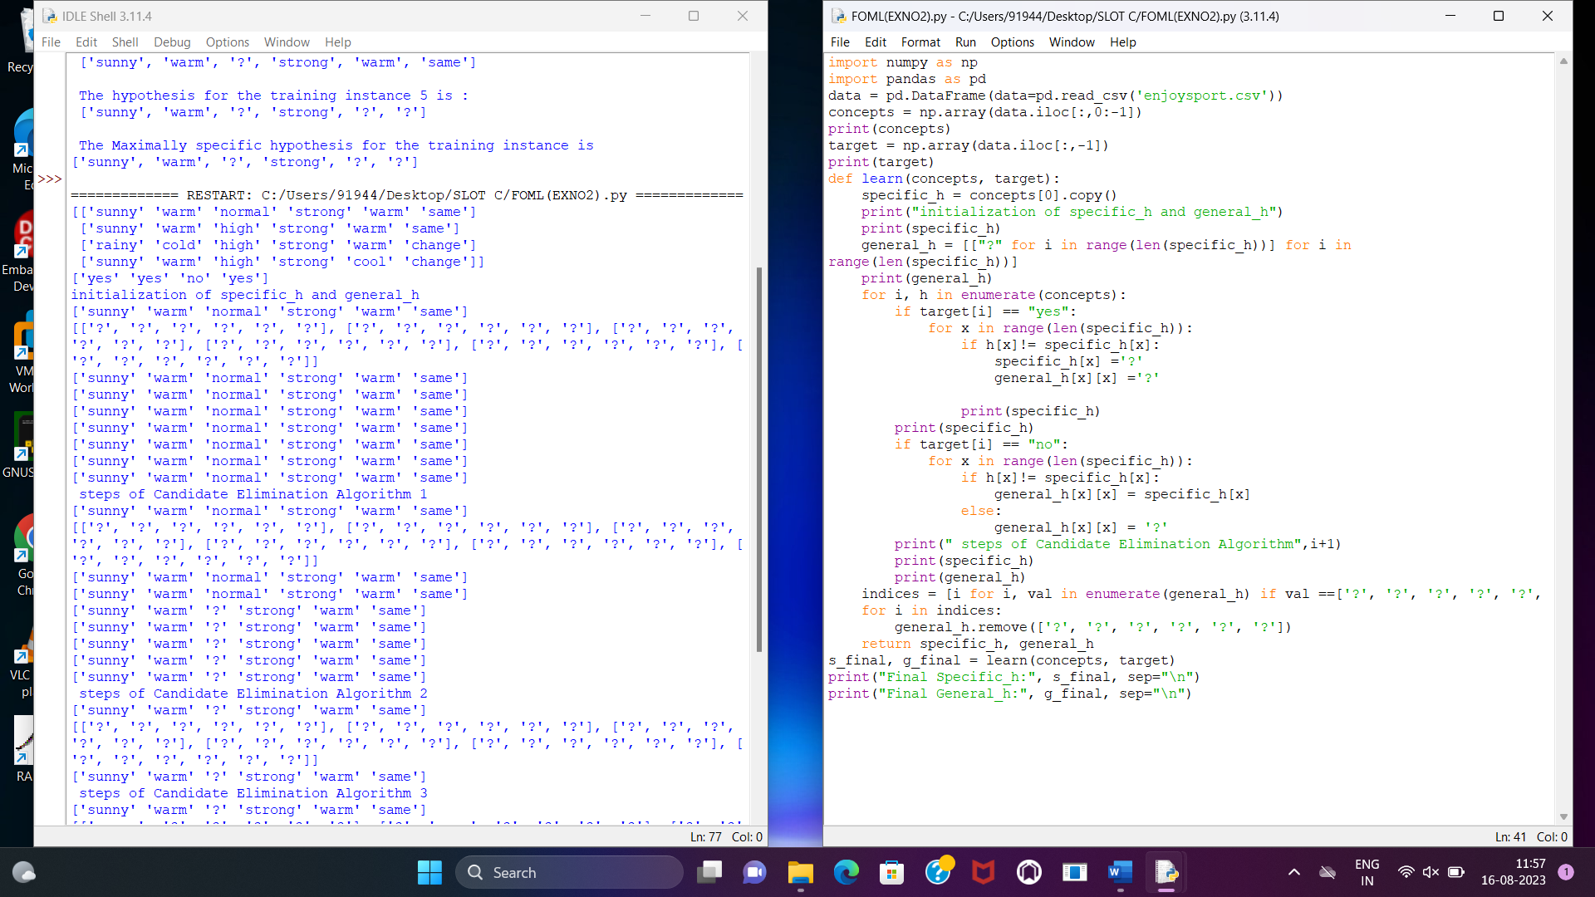

3. Demonstrate the working of the decision tree based ID3 algorithm. Use an appropriate data set for building the decision tree and apply this knowledge to classify a new sample.

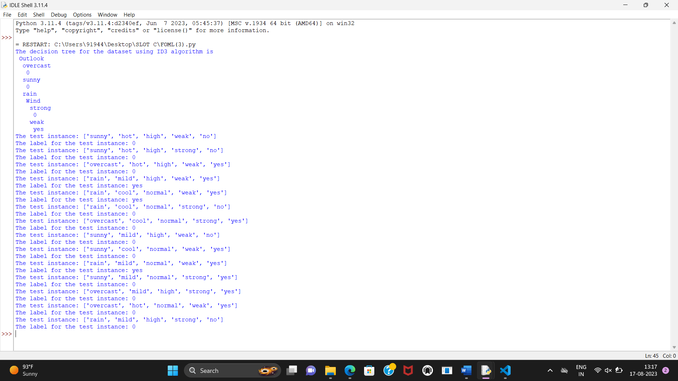

4. Build an Artificial Neural Network by implementing the Backpropagation algorithm and test the same using appropriate data sets.

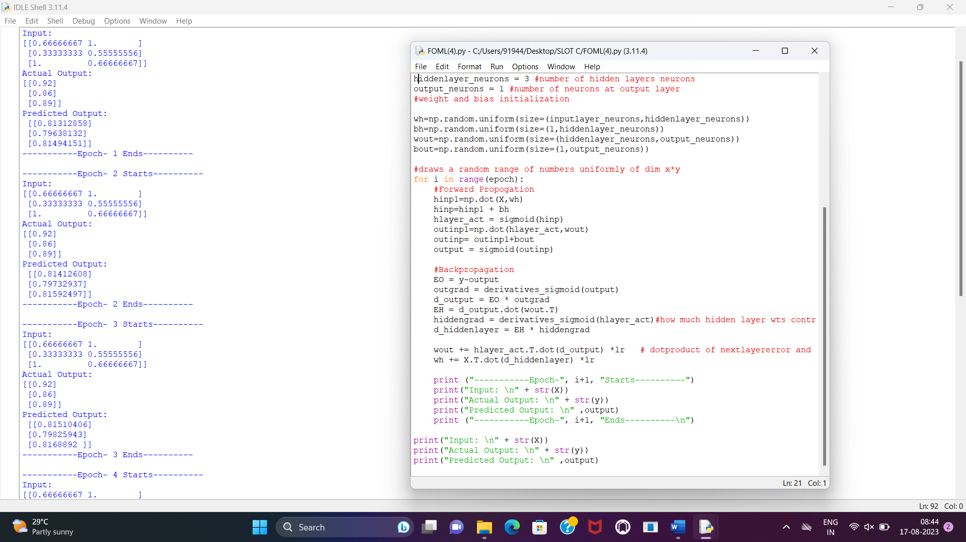

5. Write a program for Implementation of K-Nearest Neighbours (K-NN) in Python

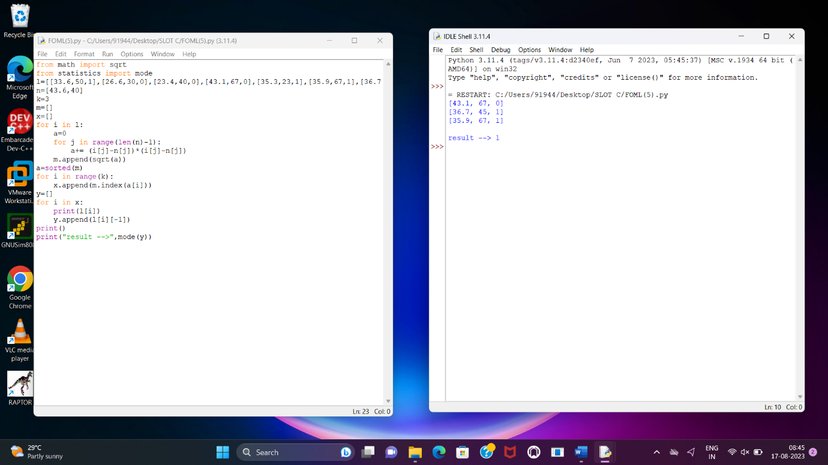

6. Write a program to implement Naïve Bayes algorithm in python and to display the results using confusion matrix and accuracy.

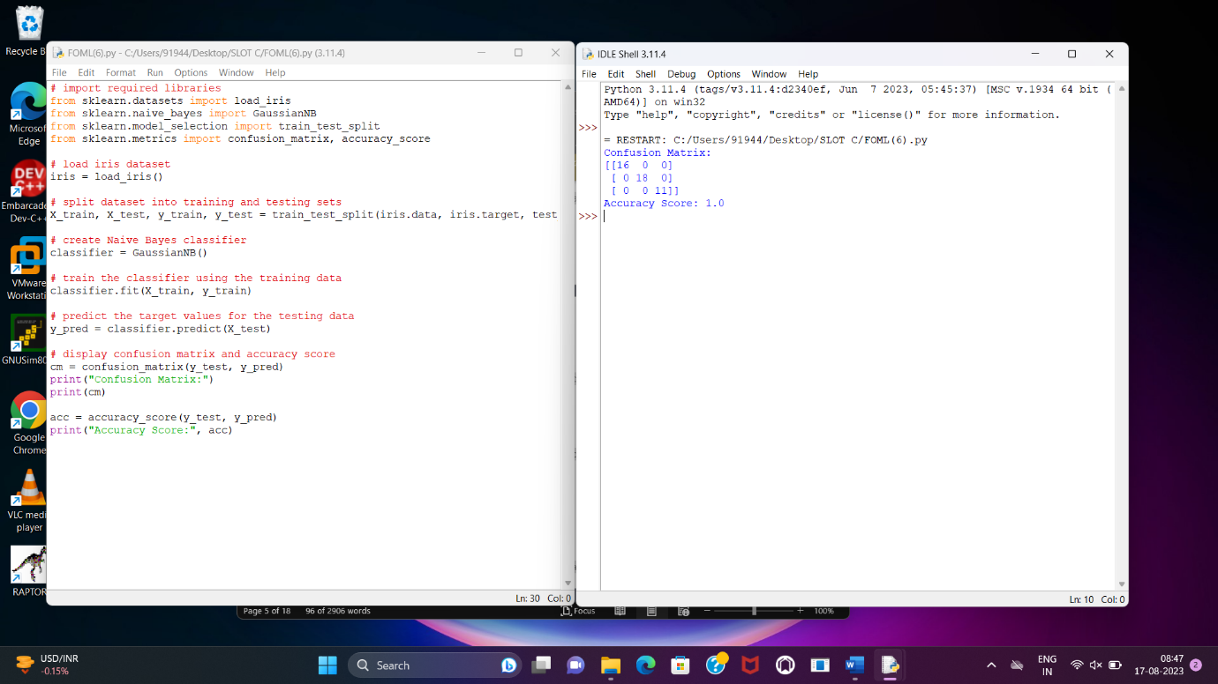

7. Write a program to implement Logistic Regression (LR) algorithm in python

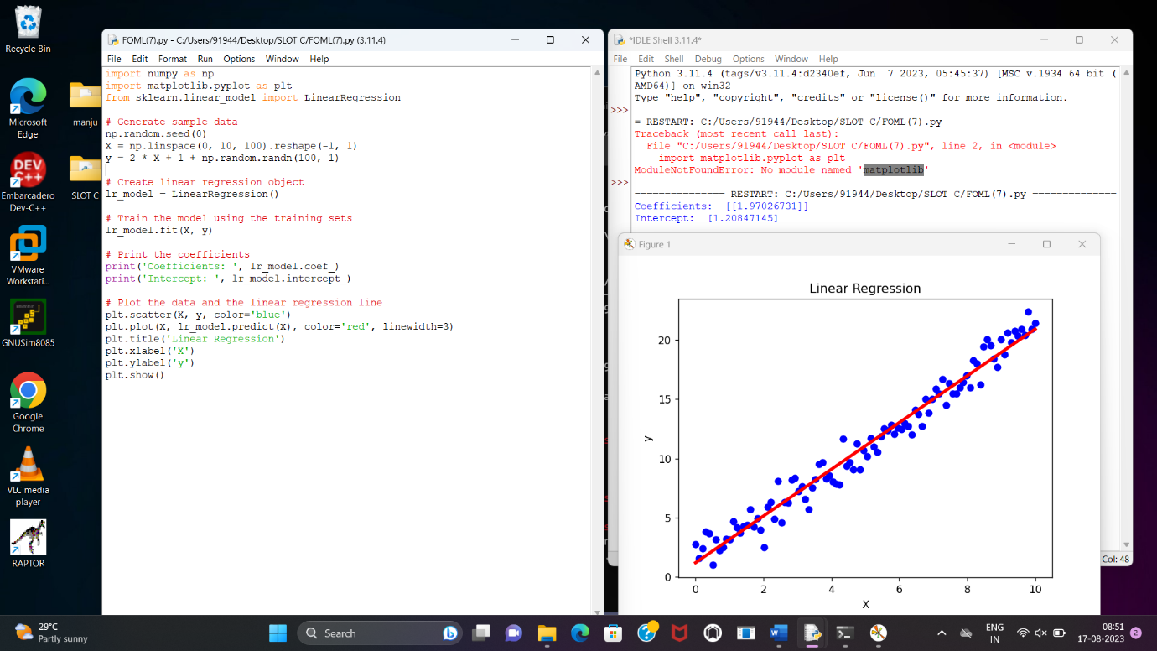

8. Write a program to implement Linear Regression (LR) algorithm in python

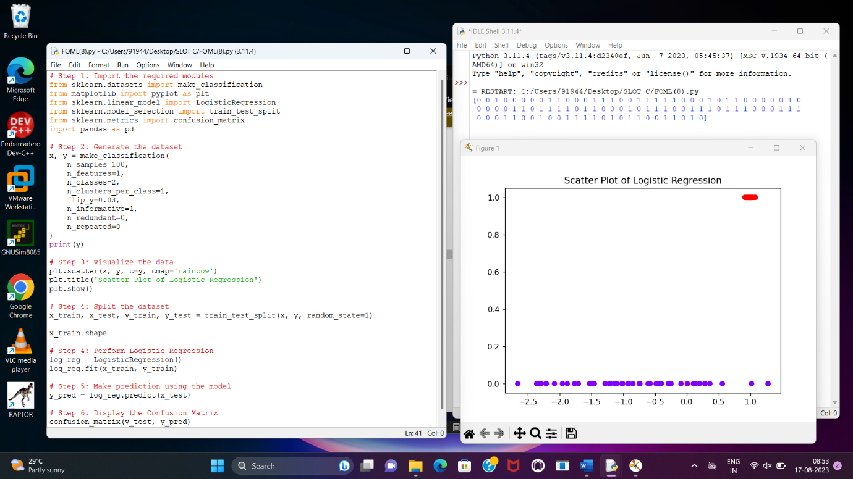

9. Compare Linear and Polynomial Regression using Python

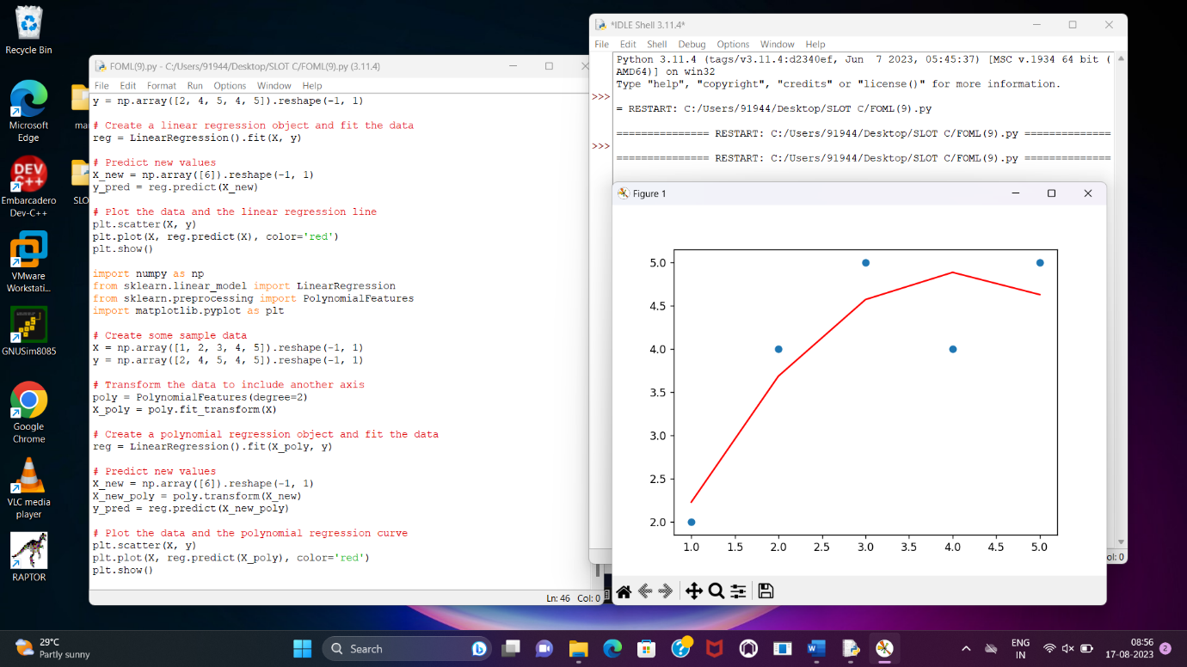

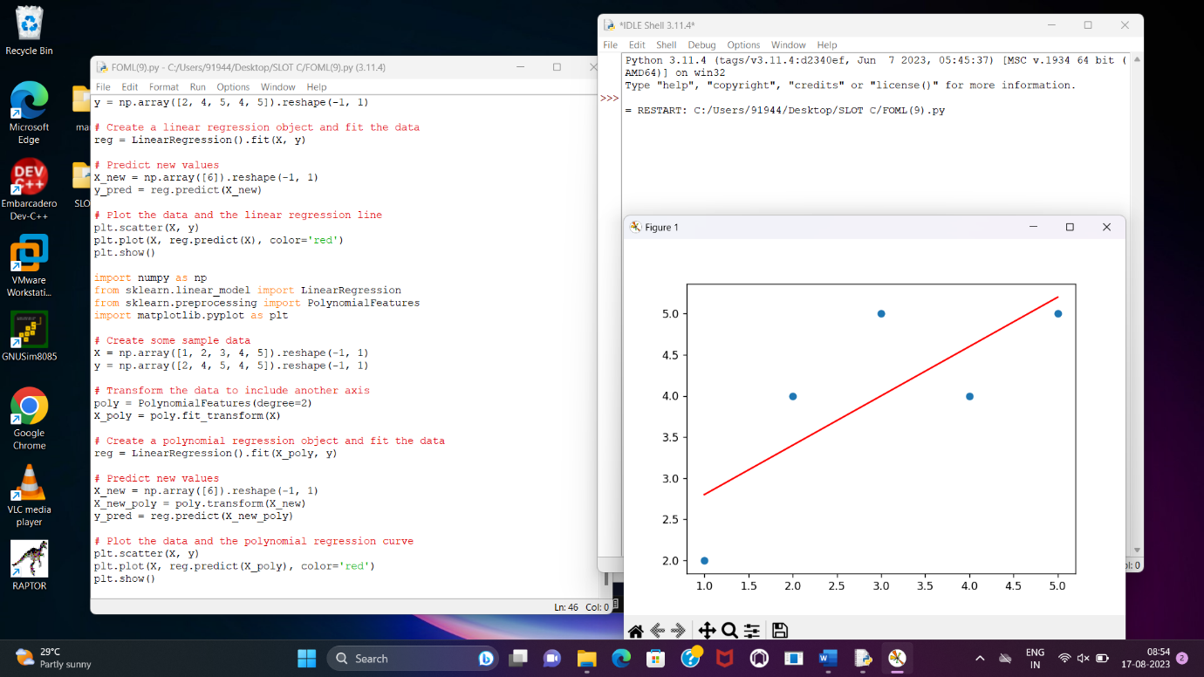

10. Write a Python Program to Implement Expectation & Maximization Algorithm

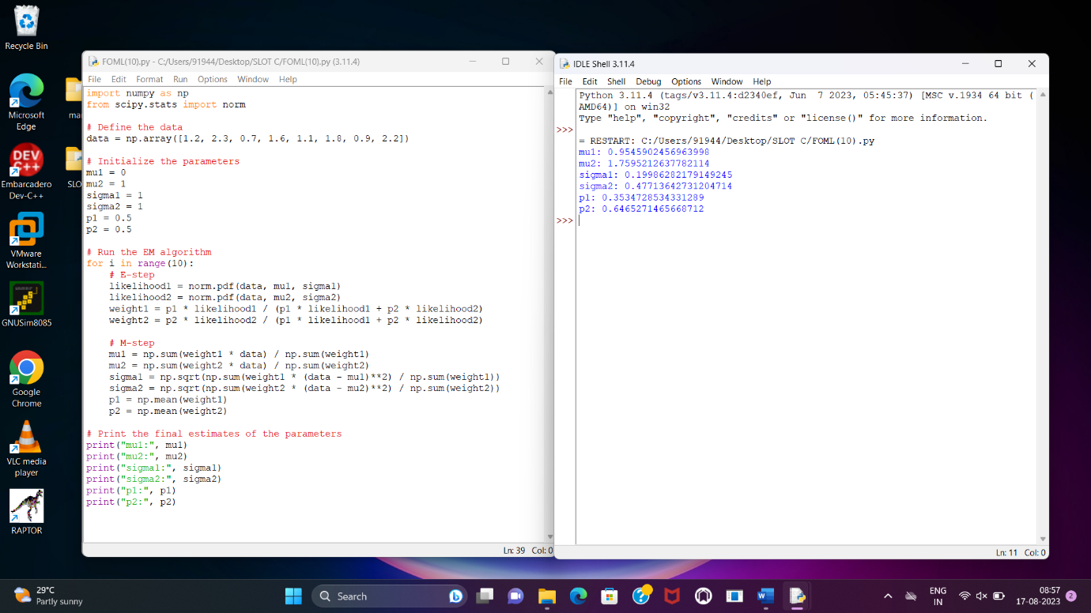

11. Write a program for the task of Credit Score Classification

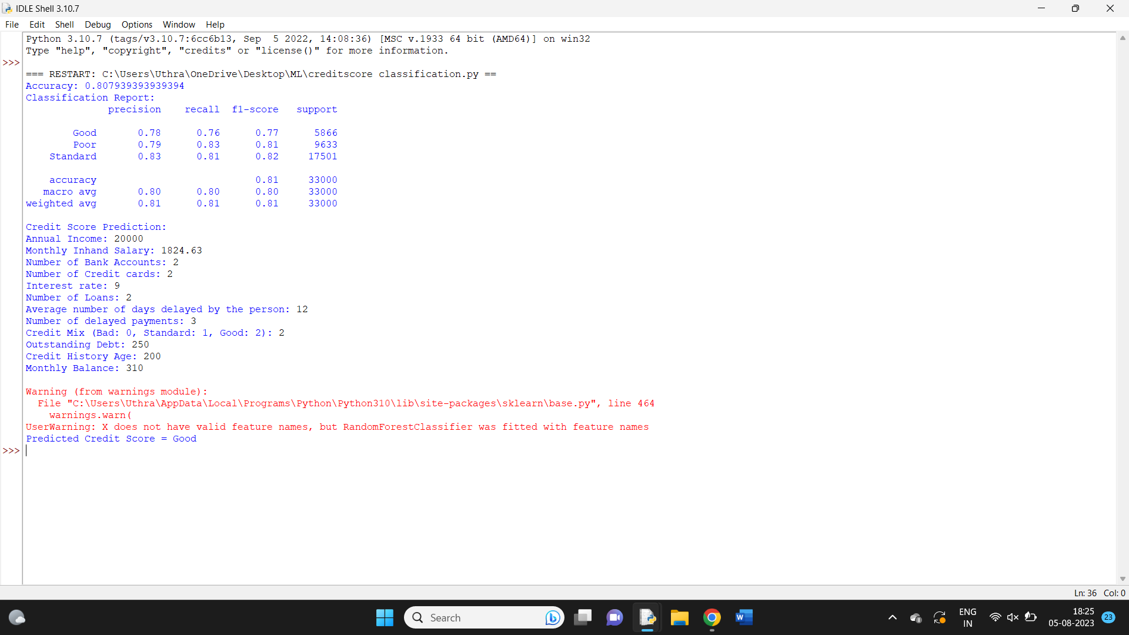

12. Implement Iris Flower Classification using KNN

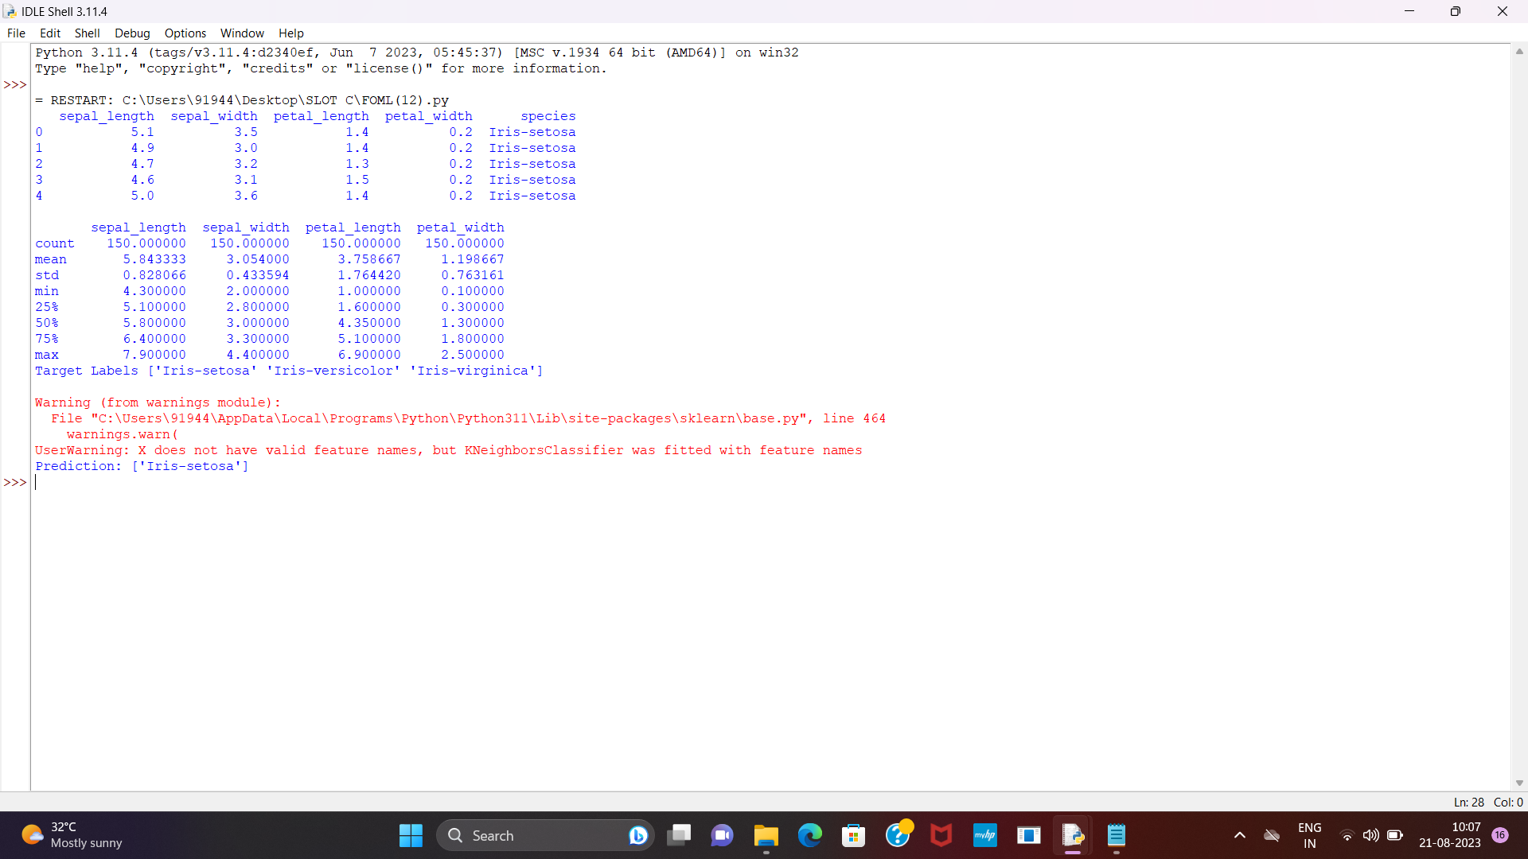

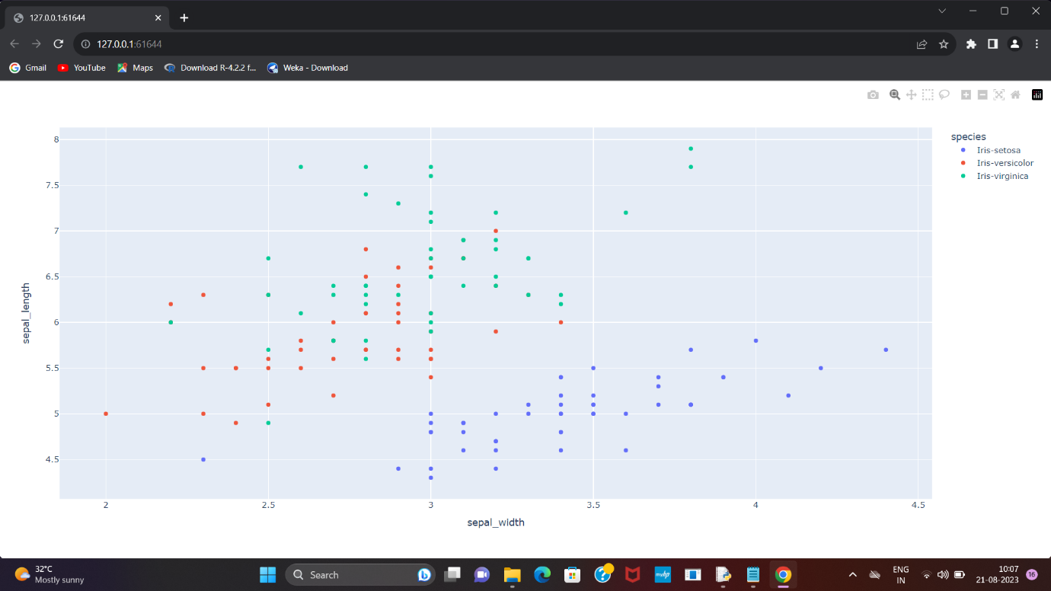

13. Implement the Car Price Prediction Model using Python

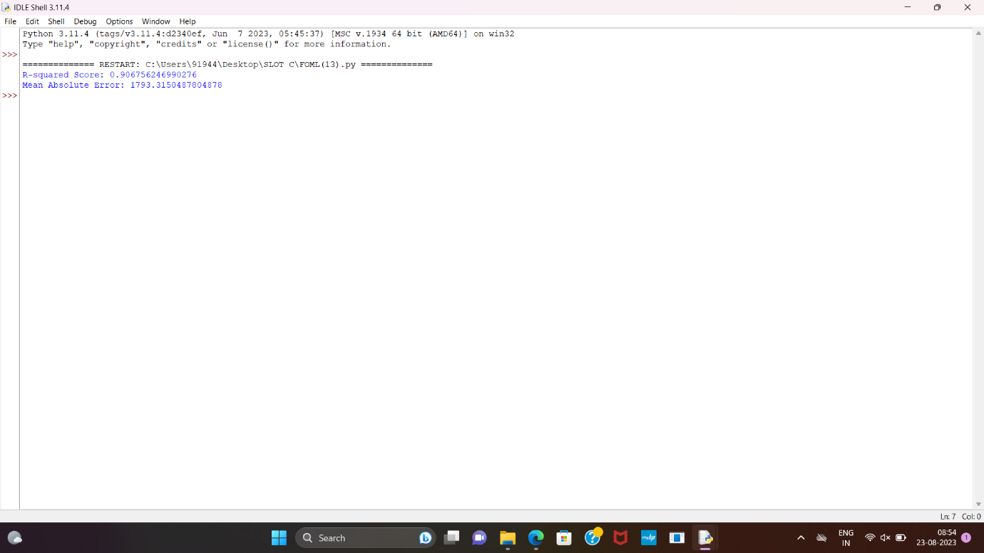

14. Implement House price Prediction using appropriate machine learning algorithm

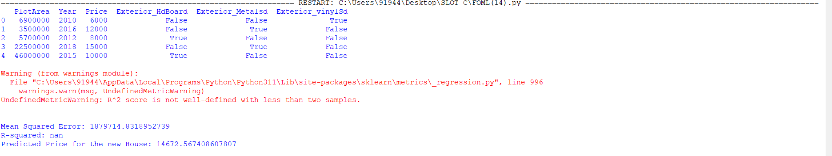

15. Implement Iris Flower Classification using Naive Bayes classifier

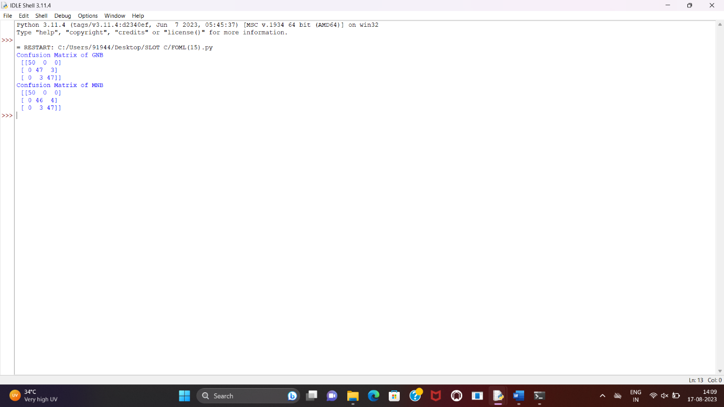

16. Compare different types Classification Algorithms and evaluate their performance.

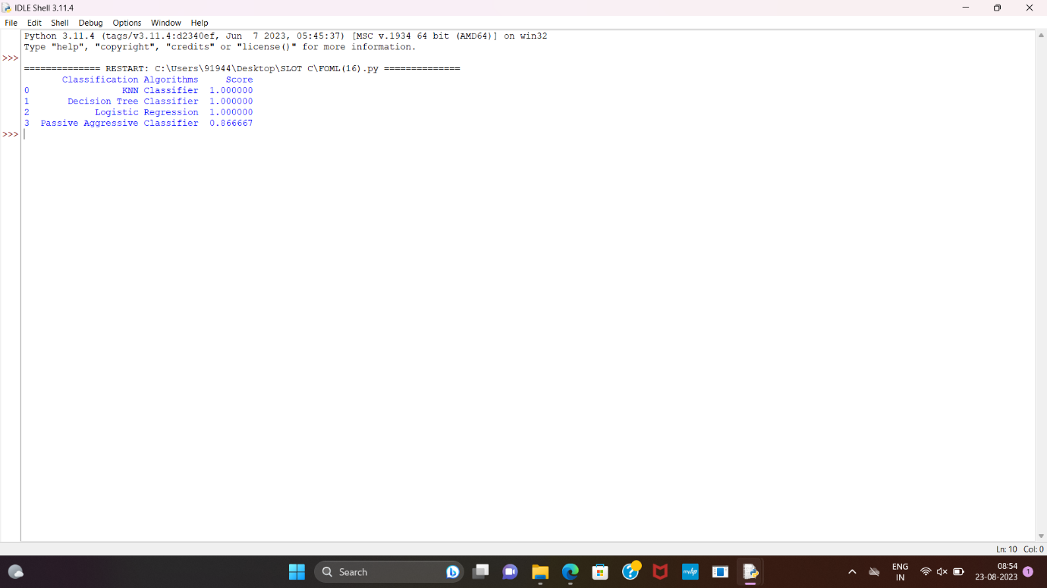

17. Implement Mobile Price Prediction using appropriate machine learning algorithm

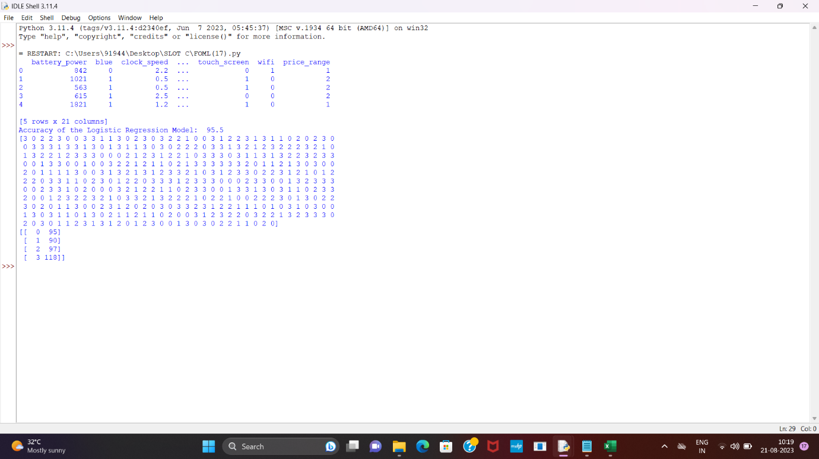

18. Implement Perceptron based IRIS classification

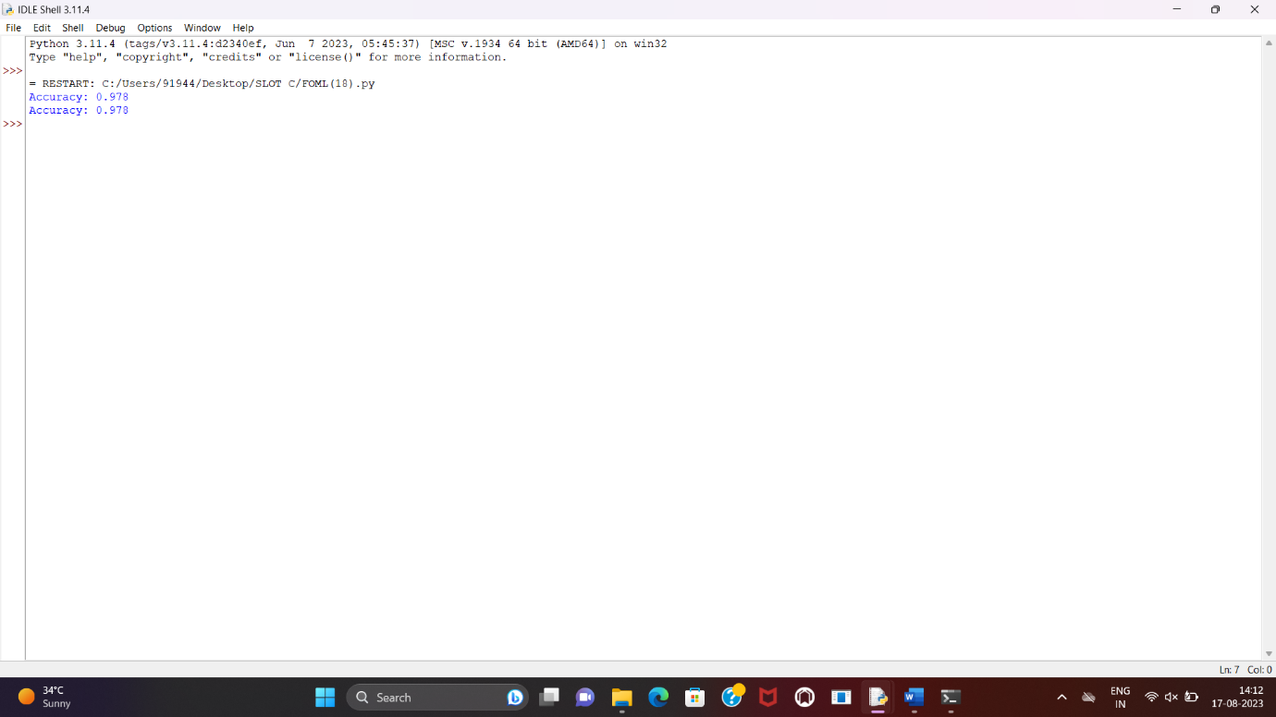

19. Implementation of Naive Bayes classification for Bank Loan prediction

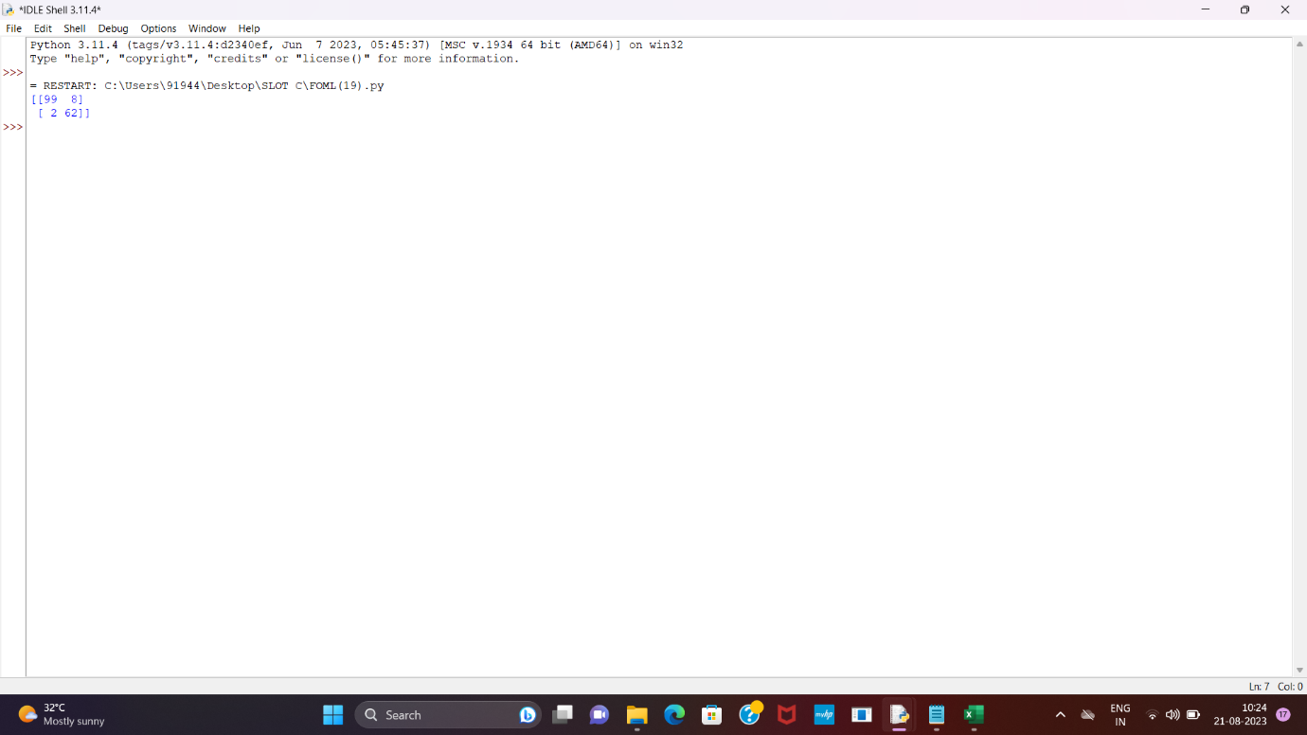

20. Implement Future Sales Prediction using a suitable machine learning algorithm

